https://www.gardeners.com/kitchen-garden-planner/preplanned-gardens?id=High_Yield

Pre-Planned Gardens
Simply choose a plan to match your planting area and types of plants you want to grow. Each square represents 1 sq. ft. and shows the number of plants, depending on the crop. The plans are designed to fit various sizes of our raised beds and elevated gardens but they can be planted in-ground as well. Continue scrolling for planting information for each crop.
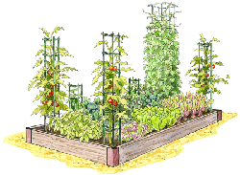
All American
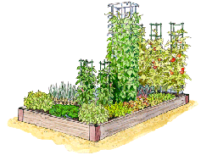
Cook's Choice
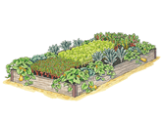
Giving Garden
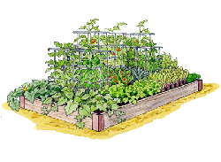
High Yield
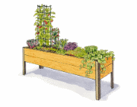
Salad Garden, 2x8
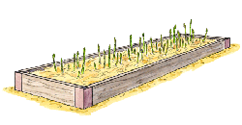
Abundant Asparagus
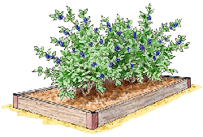
Bountiful Blueberry
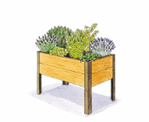
Cocktail Garden, 2x4
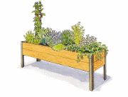
Cocktail Garden, 2x8
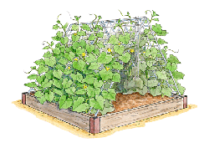
Cucumber Farm
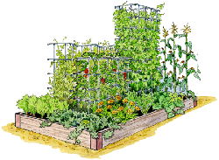
Fun for Kids
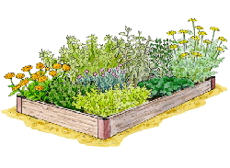
Kitchen Herb
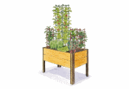
Mediterranean Garden, 2x4
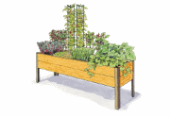
Mediterranean Garden, 2x8
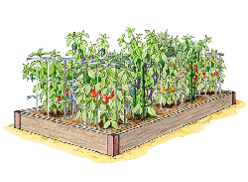
Peppers Sweet & Hot
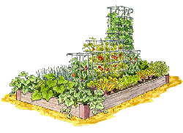
Plant It & Forget It
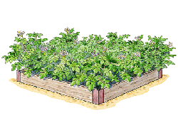
Potato Bed
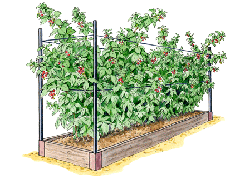
Royal Raspberry
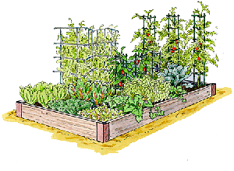
Salad Bar
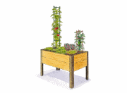
Salad Garden, 2x4
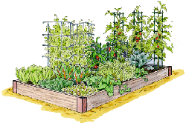
Salsa & Tomato Sauce
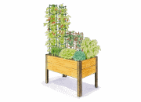
Salsa Garden, 2x4
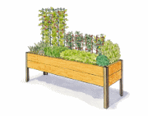
Salsa Garden, 2x8
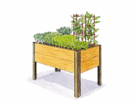
Stir Fry Garden, 2x4
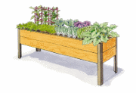
Stir Fry Garden, 2x8
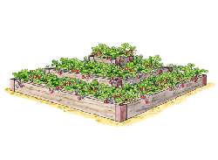
Super Sweet Strawberries
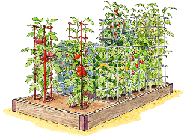
Totally Tomatoes
High Yield
Maximize your vegetable harvest with these high-performing crops. You can expect to get more than 50lbs of garden-fresh produce from this 18 sq. ft. garden.
BUY THE SEEDS
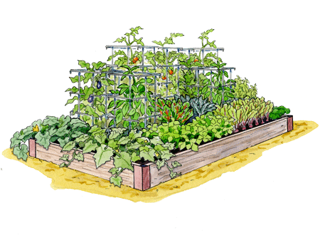
Print
Edit
Email
• 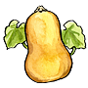
• 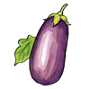
• 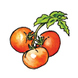
•
•
• 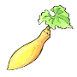
• 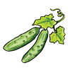
• 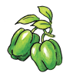
• 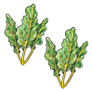
• 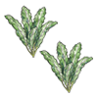
•
• 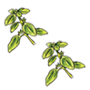
•
• 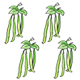
•
• 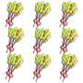
•
• 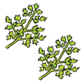

Planting Guide:

Winter squash
- There are many types, including butternut, acorn, sweet dumpling, hubbard and spaghetti squash.
- Plant seeds 3/4″ deep indoors or outdoors, three weeks after last frost, when soil is 70 degrees F.
- Transplant: three weeks after last frost, or when soil is 70 degrees F.
- Spacing: one plant per sq. ft. Grow on trellis or allow vines to run out of the garden
- Days to harvest: 85 to 100 from planting seeds, depending on variety. Pick before first frost.
- Hint: Prune growing tips to keep under control. Leave stems attached when harvesting.
Learn more about Winter squash in our Vegetable Encyclopedia

Eggplant
- Start seeds 1/4″ deep indoors eight weeks before last frost.
- Transplant seedlings when soil reaches 70 degrees F. or three weeks after last frost.
- Spacing: one per sq. ft.
- Days to harvest: 55 to 70 days from transplant. Not frost-hardy.
- Hints: Bugs love eggplants. Protect with garden fabric (row cover) even after flowering.
Learn more about Eggplant in our Vegetable Encyclopedia

Tomato
- Plant seeds 1/4″ deep indoors, six to eight weeks before last frost
- Transplant into garden one to two weeks after last frost or when soil reaches 65 degrees F.
- Spacing: one plant per sq. ft. Grow early season crops nearby to allow more room later.
- Days to harvest: 55 to 100 days from transplanting, depending on variety. Not frost-hardy
- Hint: Remove lower leaves before planting and bury extra stem.
- Buy organic tomato seeds
Learn more about Tomato in our Vegetable Encyclopedia

Summer squash
- Plant seeds 3/4″ deep indoors or outdoors three weeks after last frost, or when soil is 70 degrees F.
- Transplant three weeks after last frost, or when soil is 70 degrees F.
- When picked frequently, plants will produce continuously until frost.
- Spacing: one plant per sq. ft. for bush varieties; two plants per sq. ft. for vining types growing on trellis.
- Days to harvest: 30 to 40 days from transplant; 40 to 50 from seed. Not frost-hardy.
- Hint: Start under garden fabric (row covers) to protect from insects.
Learn more about Summer squash in our Vegetable Encyclopedia

Cucumber
- Plant seeds indoors 1/2″ deep three weeks before last frost, or seed in garden after frost.
- Transplant into garden after frost and when soil is 65 to 70 degrees F.
- Spacing one per sq. ft. for bush type; two per sq. ft. for vining type.
- Extend harvest with a second crop, planted two weeks later.
- Days to harvest: 50 to 60 days after transplanting. Not frost-hardy.
- Hint: Use row covers until flowering to keep off insects.
- Buy organic cucumber seeds
Learn more about Cucumber in our Vegetable Encyclopedia

Peppers
- Start seeds indoors 1/4″ deep 10 to 12 weeks before last frost.
- Transplant into garden three weeks after last frost or when soil reaches 70 degrees F.
- Fruits are edible from early green to full-color maturity.
- Spacing: one plant per sq. ft.
- Days to harvest: 50 to 65 days green, 80 to 85 days to full color. Not frost-hardy.
- Buy organic sweet pepper seeds
Learn more about Peppers in our Vegetable Encyclopedia

Swiss chard
- Plant seeds 1/2″ deep indoors six weeks before last frost, or in garden two weeks before last frost
- Transplant: Around the time of last frost
- Plant a second crop to ensure a plentiful supply of tender leaves.
- Spacing: two plants per sq. ft.
- Days to harvest: 30 days from seed for baby; 50 days to full size. Frost-hardy.
- Hint: Good source of summer greens, chard is not bothered by heat.
Learn more about Swiss chard in our Vegetable Encyclopedia

Kale
- Sow seeds 1/2″ deep indoors eight weeks before last frost or in garden six weeks before last frost.
- Transplant seedlings into garden up to six weeks before last frost. Very frost-hardy.
- Spacing: two plants per sq. ft. Can be planted midsummer wherever early crops are removed.
- Kale continues to grow and produce leaves until late fall.
- Days to harvest: 60 days. Very frost-hardy.
- Hint: Kale can be grown in part shade. It needs plenty of moisture, so mulch well.
Learn more about Kale in our Vegetable Encyclopedia

Basil
- Plant seeds 1/4″ deep indoors six weeks before last frost; outdoors two weeks after last frost.
- Transplant seedlings two to three weeks after last frost or when soil reaches 70 degrees F.
- Replant if you have space and want more.
- Spacing: two plants per sq. ft.
- Days to harvest: 40-55 days from transplant. Harvest leaves as desired. Not frost-hardy.
- Hint: Pinch stems early and often to stimulate branching and bushy growth.
- Buy organic basil seeds
Learn more about Basil in our Vegetable Encyclopedia

Beans
- Sow seeds 1″ deep directly in garden after all danger of frost.
- Spacing: four plants per sq. ft. for bush beans, six to eight plants per sq. ft. for pole beans
- Plant second crop of bush beans (if needed) two weeks after first planting
- Days to harvest: 50-80 days from seed, depending on variety. Not frost-hardy.
- Hint: Add a legume inoculant when planting to increase vigor and yield.
- Buy organic bean seeds
Learn more about Beans in our Vegetable Encyclopedia

Beet
- Sow seeds 1/2″ deep directly in garden five to six weeks before last frost.
- Spacing: Plant seeds 18 per sq. ft., thin to nine plants
- Plant more in midsummer for a fall harvest
- Days to harvest: 45 to 60. Frost-hardy.
- Hint: The longer you wait to harvest, the bigger the beets. Tops and thinnings are flavorful.
- Buy organic beet seeds
Learn more about Beet in our Vegetable Encyclopedia

Parsley
- Start seeds 1/4″ deep indoors 10 to 12 weeks before last frost.
- Transplant seedlings into garden up to a month before last frost.
- Spacing: two plants per sq. ft.
- Edible all summer and into winter.
- Biennial: plants will go to seed second year.
- Days to harvest: 75. Begin harvesting foliage at any time. Very frost-hardy.
- Hint: Parsley takes up to 21 days to germinate. Treat seeds with hot water before planting.
Learn more about Parsley in our Vegetable Encyclopedia

